**Lab03/04-AWS Database Practices (RDS, SQL Server, DynamoDB)**

* Create Instance from RDS –SQL Server
* Create Instance from DynamoDB (NoSQL)

Required screen capture are ;

RDS database -> Step 2f

DynomoDB database -> Step3.5

This lab works on Free-Tier and cost to you $2 per/day

Also, you can perform this lab in the AWS Academy Learner Lab

MAKE SURE TO DELETE YOUR RDS in the end.

Amazon RDS :

Amazon Relational Database Service (Amazon RDS) makes it easy to set up, operate, and scale a relational database in the cloud. It provides cost-efficient and resizable capacity while automating time-consuming administration tasks such as hardware provisioning, database setup, patching and backups. It frees you to focus on your applications so you can give them the fast performance, high availability, security and compatibility they need.

Amazon RDS is available on several database instance types - optimized for memory, performance or I/O - and provides you with six familiar database engines to choose from, including Amazon Aurora, PostgreSQL, MySQL, MariaDB, Oracle Database, and SQL Server. You can use the AWS Database Migration Service to easily migrate or replicate your existing databases to Amazon RDS.

Amazon DynamoDB:

Amazon DynamoDB is a key-value and document database that delivers single-digit millisecond performance at any scale. It's a fully managed, multiregion, multimaster, durable database with built-in security, backup and restore, and in-memory caching for internet-scale applications.

Hundreds of thousands of AWS customers have chosen DynamoDB as their key-value and document database for mobile, web, gaming, ad tech, IoT, and other applications that need low-latency data access at any scale.

**Amazon RDS**

## **Step 1: Enter the RDS Console**

Login to AWS Console and find the RDS under *Database*and click to open the Amazon RDS Console.

## **Step 2: Create a Microsoft SQL Server DB Instance**

In this step, we will use Amazon RDS to create a Microsoft SQL Server DB Instance with db.t2.micro DB instance class, 20 GB of storage, and automated backups enabled with a retention period of one day.

a. In the top right corner of the Amazon RDS console, select the *Region*in which you want to create the DB instance.

Note: AWS Cloud resources are housed in highly available data center facilities in different areas of the world. Each Region contains multiple distinct locations called Availability Zones. You have the ability to choose which Region to host your Amazon RDS activity in.

b.   In the Create database section, choose Create database.

c.  The creation method will be “Standard Create,” using the free-tier version. We will modify the database after creating it. You now have options to select your engine. For this tutorial, click the *Microsoft SQL Server* icon. Select “Free Tier”.

d. Create a master password for your database and make a note of it(it will be used to access the database).

“Public Access” has to be on.

e. You don’t need to check the box “Turn on Performance Insights”. Uncheck the box as shown in the snapshot below. Follow the snapshots further.

Uncheck “Turn on Performance insights”.

f. Click on “Create Database”. Your DB Instance is now being created.  Click View Your DB Instances.

Note: Depending on the DB instance class and storage allocated, it could take several minutes for the new DB instance to become available.

The new DB instance appears in the list of DB instances on the RDS console. The DB instance will have a status of *creating*until the DB instance is created and ready for use.  When the state changes to *available*, you can connect to a database on the DB instance.

Feel free to move on to the next step as you wait for the DB instance to become available.

**< Capture needed here – show your database instances> Click on the DB identifier**

## **\*\* You can do step 3 and 4 for learning purposes, a capture is not required. You can download an sql express client by browsing on google, download it and can connect to your database \*\***

## **Step 3: Download an SQL Client (optional step)**

Once the database instance creation is complete and the status changes to available, you can connect to a database on the DB instance using any standard SQL client. In this step, we will download Microsoft SQL Server Management Studio Express, a popular client for SQL Server.

a. Go to the [Microsoft Download Center - Microsoft SQL Server Management Studio Express](https://www.microsoft.com/en-us/download/details.aspx?id=104781) page and click Continue.

Note: Remember to download the SQL client to the same device from which you created the RDS DB Instance. The security group your database is placed in is configured to allow connection only from the device from which you created the DB instance.

b. You will be prompted to register with Microsoft -- this step is not required for download.  You can skip registration by selecting the radio button next to '*No, I do not want to register. Take me to the download*' and click Next on the popup modal.

Then, select the SQL Management Studio you need and click Next to start your download.

## **Step 4: Connect to the Microsoft SQL Server Database (optional step BUT MAKE SURE TO DELETE YOUR RDS TO AVOID CHARGES)**

In this step, you will connect to the database you created using SQL Server Management Studio.

a. Once you have completed your download, install and open the program. A dialog box appears.  Enter the following:

* Server type: Select Database Engine
* Hostname: Copy and paste the hostname from the Amazon RDS console as shown in the screenshot to the right. Afterwards, change the colon between the DNS and port number to a comma. For example, your server name should look like  sample-instance.cg034hpkmmjt.us-east-1.rds.amazonaws.com,1433.
* Username: Type in the username you created for the Amazon RDS database.  Our example is '*masterUsername*.'
* Password: Enter the password you used while creating the Amazon RDS database.

Click Connect.

b. You are now connected to the database. In the SQL Server Management Studio, you will see various schema objects available in the database. Now you can start creating tables, insert data, and run queries.

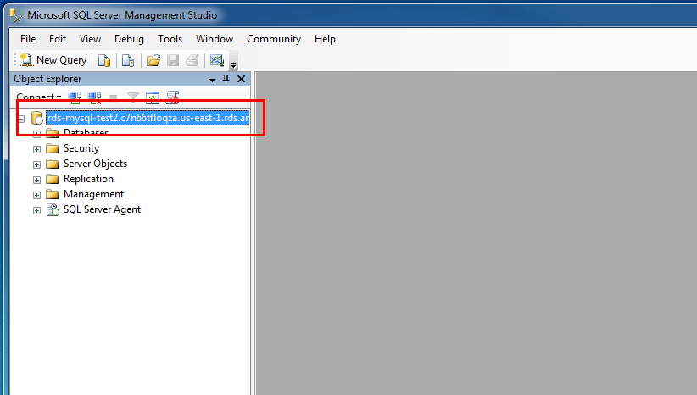

## **Step 5: Delete the DB Instance**

You can easily delete the Microsoft SQL Server DB Instance from the Amazon RDS console. It is a best practice to delete instances that you are no longer using so that you don’t keep getting charged for them.

a. Go back to your Amazon RDS Console.  Select Databases, choose the instance that you want to delete, and then select Delete from the Actions dropdown menu.

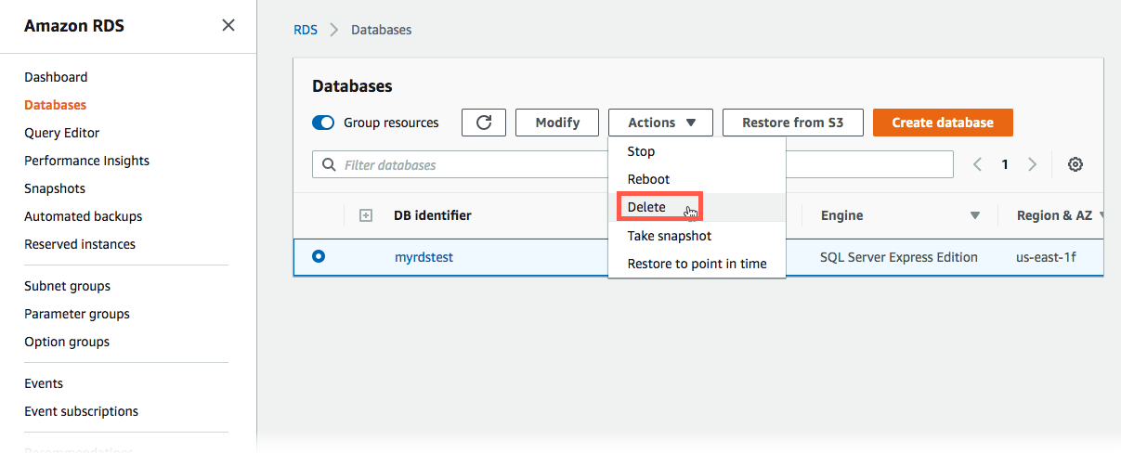

b. You are asked to create a final snapshot. For our example, do not create a final snapshot, acknowledge that you want to delete the instance, and then click Delete.

    Note: Deleting your DB Instance may take a few minutes.

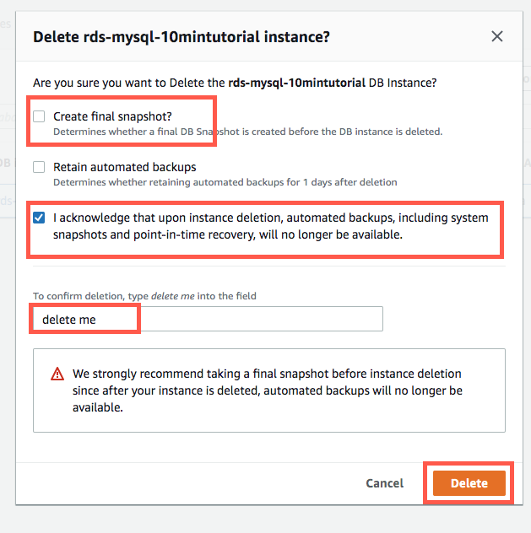

**Amazon DynamoDB**

Step1: To create a new Music table using the DynamoDB console:

1. Sign in to the AWS Management Console and open the DynamoDB console at <https://console.aws.amazon.com/dynamodb/>.
2. In the navigation pane on the left side of the console, choose **Dashboard**.
3. On the right side of the console choose **Create Table**.

1. Enter the table details as follows:
   1. For the table name, enter **Music**.
   2. For the partition key, enter **Artist**.
   3. Enter **SongTitle** as the sort key.
2. Choose **Create** to create the table.

Step 2: insert some data into DB.

1. In the navigation pane on the left side of the console, choose **Tables**.
2. In the table list, choose the **Music** table.
3. Go to **Actions** tab for the **Create item** table.A screenshot of a computer

   Description automatically generated with medium confidence
4. Click “Add new attribute” and create **Awards** of type **Number**.

1. Repeat this process to create an **AlbumTitle** of type **String**.
2. Choose the following values for your item:
   1. For **Artist**, enter **No One You Know** as the value.
   2. For **SongTitle**, enter **Call Me Today**.
   3. For **AlbumTitle**, enter **Somewhat Famous**.
   4. For **Awards**, enter **1**.

1. Choose **Create item**.


                                Console screenshot showing the completed fields for the
                                    item.
                            

1. Repeat this process and create another item with the following values:
   1. For **Artist**, enter **Acme Band**.
   2. For **SongTitle** enter **Happy Day**.
   3. For **AlbumTitle**, enter **Songs About Life**.
   4. For **Awards**, enter **10**.

Step 3: Query the Database

1. In the navigation pane on the left side of the console, choose **Tables**.
2. Choose the **Music** table from the table list.
3. Choose the **Explore table items** tab for the Music table.
4. Choose **Query**.

1. For **Partition key**, enter **No One You Know**, and then choose **Run**.

